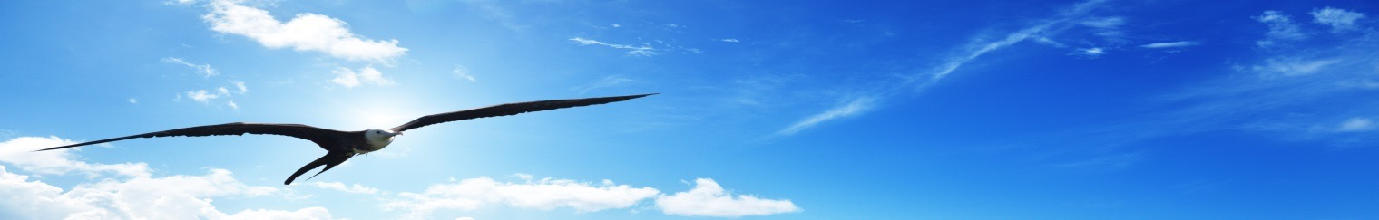
NATO DEFENSE COLLEGE FOUNDATION
STRATEGIC TRENDS
February 2016
AFRICA
Somalia: countering Al-Shabaab and opening the political horizon
The wave of terrorist attacks affecting Somalia’s territory, especially in some southern and central crucial areas around Mogadishu, which are contested by the Al-Shabaab armed group, continues to upset the country. The latest terror attack occurred in Baidoa on the 28th of February and hit several civilians.
The same day in Djibouti the heads of the state and government of the countries contributing troops to the African Union mission AMISOM concluded a summit whose main purpose was to reinforce military operations in Somalia and effectively tackle the Al-Shabaab threat. Presidents of Somalia, Djibouti, Kenya attended the summit together with Ethiopian and Ugandan Prime Ministers, and Nigeria and Burundi Defence Ministers. They agreed on urgent issues like the necessity to identify and stifle Al-Shabaab’s financial channels and reduce the recruitment of foreign fighters in its ranks. Furthermore, the need for a better-coordinated effort of the Somali National Security Forces with AMISOM operations was stressed in the meeting.
AMISOM has indeed experienced many difficulties, leading to a sharp drop of its offensive capability precisely due to a lack of coordination between the troops of different countries and to dissensions within the mission’ bodies. The Kenyan contingent is still source of political frictions due to Nairobi’s interest in controlling some Somali bordering oilfields.
At an internal level the AMISOM adventure, sponsored by President Uhuru Kenyatta but currently contested by public opinion, has led to the intensification of terrorist attacks on Kenyan soil too. If one adds the Al-Shabaab attack carried out last 15th of January against the El-Adde military camp (Gedo region), that killed hundreds of soldiers, mostly Kenyans, who were declared target of the attack, one can gauge the public mood in Nairobi.
At the same time Burundian troops are increasingly inactive due to their country’s political crisis. Hence the lead role in the mission was assigned to Uganda, which it is responsible for the demanding task of organizing counterguerrilla operations, despite funding cuts. For these reasons AMISOM will probably hobble as long as the political and operational tensions are not solved, as wished by the summit.
The neutralisation of Shabaab is possible through a combination of interdiction operations against jihadist infiltrations and a series of military offensives co-ordinated between AMISOM and the Somali National Army in order to liberate the pivot areas in the South, actually controlled by the guerrillas. Consequently the mid-term scenario will be characterised by a string of military offensives and terrorist attacks, until the tipping point will be reached by common political action within AMISOM, depriving al-Shabaab of the main plank for enlarging its sphere of influence.
The long-term scenario instead will revolve around next presidential elections by August 2016; these will be the first ones with a new system since 47 years, marking the future Somali internal reconciliation, leading to necessary political and military reforms that will lead to the crumbling Al-Shabaab.

